CHAPTER THREE
OVERLOAD POWER SYSTEM

3.1 Overview
A power system continually experiences changes in its operating state. The emergency state may occur as a result of a sudden increase in system demand, the unexpected outage of a generator or a transmission line, or a failure in any of the system components. This chapter represents the main causes of overload in power system and simple efficient solutions for alleviation overloads.

3.2 Basic Load Characterization
Load is the apparent power in megavolt-amperes, kilovolt-amperes, or volt-amperes that may be transferred by the transformer. A number of terms are used to characterize the magnitude and intensity of loads. Several such terms are defined and uses outlined below.

3.2.1 Energy
Energy use (over a specified period of time) is a key identifying parameter for power system loads. Energy use is often recorded for various portions of the power system (e.g., homes, businesses, feeders, substations, districts). Utilities report aggregate system energy use over a variety of time frames (daily, weekly, monthly, and annually). System energy use is tied directly to sales and thus is often used as a measure of the utility or system performance from one period to another [20].

3.2.2 Demand
Loads require specific amounts of energy over short periods of time. Demand is a measure of this energy and is expressed in terms of power (kilowatts or Megawatts). Instantaneous demand is the peak instantaneous power use of a device, facility, or system.
Demand, as commonly referred to in utility discussions, is an integrated demand value, most often integrated over 10, 15, or 30 min. Integrated demand values are determined by dividing the energy used by the time interval of measurement or the demand interval.
$\text{Demand}=\frac{\text{Energy}\text{Use}}{\text{Demand}\text{Interval}}$ (3.1)
Integrated demand values can be much lower than peak instantaneous demand values for a load or facility [20].

3.2.3 Demand Factor
Demand factor is a ratio of the maximum demand to the total connected load of a system or the part of the system under consideration. Demand factor is often used to express the expected diversity of individual loads within a facility prior to construction. Use of demand factors allows facility power system equipment to be sized appropriately for the expected loads [20].
$\text{Demand}\text{Factor}=\frac{\text{Muximum}\text{Demand}}{\text{Total}\text{Connected}\text{Load}}$ (3.2)

3.2.4 Load Factor
Load factor is similar to demand factor and is calculated from the energy use, the demand, and the period of time associated with the measurement.
$\text{Load}\text{Factor}=\frac{\text{Energy}\text{Use}}{\text{Demand}×\text{Time}}$ (3.3)

A high load factor is typically desirable, indicating that a load or group of loads operates near its peak most of the time, allowing the greatest benefit to be derived from any facilities installed to serve the load [20].

3.2.5 Coincidence and Diversity
Although individual loads vary unpredictably from hour to hour and minute to minute, an averaging effect occurs as many loads are examined in aggregate. This effect begins at individual facilities (home, commercial establishment, or industrial establishment) where all devices are seldom if ever in operation at the same instant. Progressing from an individual facility to the distribution and transmission systems, the effect is compounded, resulting in somewhat predictable load characteristics.
Diversity is a measure of the dispersion of the individual loads of a system under observation over time. Diversity is generally low in individual commercial and industrial installations. However, at a feeder level, diversity is a significant factor, allowing more economical choices for equipment since the feeder needs to supply power to the aggregate peak load of the connected customers, not the sum of the customer individual (non coincident) peak loads.
Groups of customers of the same class (i.e., residential, commercial, industrial) tend to have an aggregate peak load per customer that decreases as the number of customers increases. This tendency is termed coincidence and has significant impact on the planning and construction of power systems. For example, load diversity would allow a feeder or substation to serve a number of customers whose individual (non coincident) peak, demands may exceed the feeder or substation rating by a factor of two or more.
$\text{Coincidence}\text{Factor}=\frac{\text{Aggregate}\text{Demand}\text{for}a\text{Group}\text{of}\text{Customers}}{\text{Sum}\text{of}\text{Individual}\text{Customer}\text{Demand}}$ (3.4)
There is a minor but significant difference between coincidences (and its representation as a coincidence factor) and the demand factor discussed above. The coincidence factor is based on the observed peak demand for individuals and groups, where as the demand factor is based on the connected load [20].

3.3 Load Curves and Load Duration
Load curves and load duration curves graphically convey very detailed information about the characteristics of loads over time. Load curves typically display the load of a customer class, feeder, or other portion of a power system over a 24-hour period. Load duration curves display the cumulative amount of time that load levels are experienced over a period of time [20].
Load curves represent the demand of a load or groups of load over a period of time, typically 24 hours.
The curves provide typical load levels for a customer class on an hour-by-hour or minute-by-minute basis. The curves themselves represent the demand of a certain class of customers or portion of the system. The area under the curve represents the corresponding energy use over the time period under consideration. Load curves provide easily interpreted information regarding the peak load duration as well as the variation between minimum and maximum load levels.
Load curves provide key information for daily load forecasts allowing planners and operators to ensure system capacity is available to meet customer needs. Three sample load curves (for residential, commercial, and industrial customer classes) are shown in Figure 3.1 through Figure 3.3 [20].
Load curves can also be developed on a feeder or substation basis, as a composite representation of the load profile of a portion of the system.

Figure 3.1 Residential Load Curve [20]

Figure 3.2 Commercial Load Curve

Figure 3.3 Industrial Load Curve [20]

Load duration curves quickly convey the duration of the peak period for a portion of a power system over a given period of time. Load duration curves plot the cumulative amount of time that load levels are seen over a specified time period. The information conveyed graphically in a load duration curve, although more detailed, Load duration curves are often characterized by very sharp ascents to the peak load value. The shape of the remainder of the curves varies based on utilization patterns, size, and content of the system for which the load duration curve is plotted.

3.4 Transfer of Active and Reactive Power
The P-V curve describes graphically the impact of an increase in real power (MW) due to consumer demand and system voltages. As the demand of reactive power (MVAR) is increased due to higher power transfer on lines driven by consumer demand, system voltages will decrease. The end of the curve, frequently called the nose, represents the maximum load that can be served. The difference between the operating load point and the maximum load point is the real power (MW) margin and is required to maintain reliability.
The voltage at which the maximum load point occurs is called the critical voltage; a critical voltage below the normal range represents a reliable and stable operating system.
For two buses simple power system shown in figure 3.4, the p-v curve will be as in figure 3.5 [28].
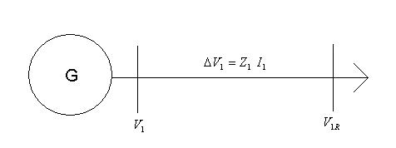
Figure 3.4 Simple Power System [29]

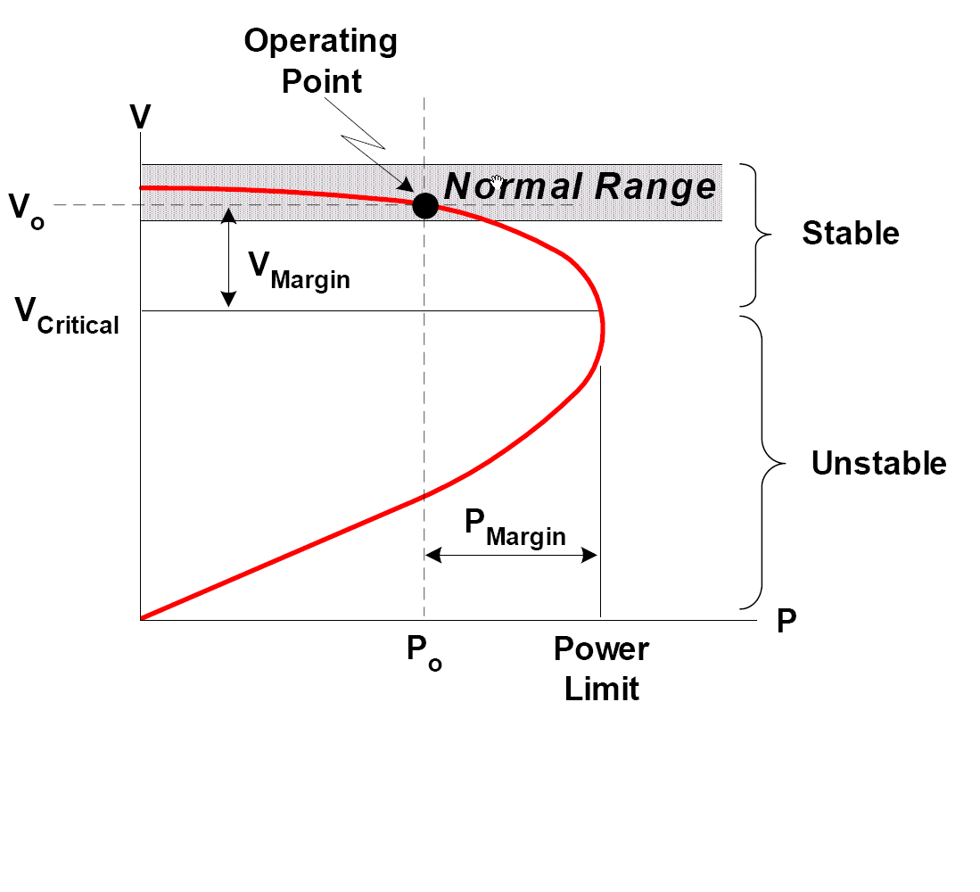
Figure 3.5 Real Power-Voltage (PV) Curve [28]

The short circuit apparent power at the receiving end$S_{1\text{SCR}}$, is given by [30]:
$S_{1\text{SCR}} = V_{1^{2}}Z_{1}$ (3.5)
and the transmitted active and reactive powers($P_{1}$,$Q_{1}$) are controlled according to the equation
$P_{1^{2}} + Q_{1}S_{1\text{SCR}} ≤ {\left(\frac{S_{1\text{SCR}}}{2}\right)}^{2}$ (3.6)
Some preliminary observations that can be made from the condition (3.6) are [30]:
- The maximum possible active power transport is$S_{1\text{SCR}} /2$ for $Q_{1} = 0$
- The maximum possible reactive power transport is$S_{1\text{SCR}} /4$ for $P_{1} = 0$
3.5 Voltage Collapse
Voltage collapse is a system instability that involves several power system components simultaneously. It typically occurs on power systems that are heavily loaded, faulted and/or has reactive power shortages. This occurs since voltage collapse is associated with the reactive power demands of loads not being met due to limitations on the production and transmission of reactive power [31].
The production limitations include generator and SVC reactive power limits and the reduced reactive power produced by capacitors at low voltages. The primary limitations in transmission are high reactive power losses on heavily loaded lines and line outages. Reactive power demands may also increase due to changes in the load such as, motor stalling or increased proportion of compressor load [31].
The dynamics of voltage phenomena can be divided into the two main groups: short- and long-term dynamics. Short-term phenomena act on a time scale of seconds or shorter and include, for example, the effect of generator excitation controls, induction motor recovery/stalling dynamics and FACTS devices.
The long-term dynamic phenomena act on a time scale of minutes and include, for example, the effect of recovery dynamics in heating load and the effect of generator over current protection systems.
In other word the analyses of real voltage collapses have shown their wide area nature and that they can be sorted basically into two categories according to the speed of their evolution Transient voltage instability and long-term voltage instability . Transient Voltage Instability is in the range of seconds (usually 1 – 3 s) and the main role in the incidents played the dynamics of induction motors as a load (majority of air conditioning systems) and HVDC transmission systems [32].
The time scale of the long-term voltage instability ranges from tens of seconds up to several minutes. It involves mainly impact of a topology change or gradual load increase, example fairly slow dynamics. Therefore the major part of the research activities in this area has focused on the steady state aspects of voltage stability, example finding the maximum load ability point of the PV-curve [32].
So voltage collapse takes place on the different timescales ranging from seconds to hours. And it’s categorized as short and long term voltage phenomena into [31]:
- Electromechanical transient (e.g., generators, regulators, induction machines) and power electronic (e.g. SVC, HVDC) phenomena in the time range of seconds.
- Discrete switching devices, such as, load tap changers and excitation limiters acting at intervals of tens of seconds.
- Load recovery processes spanning several minutes.
There are numerous power system events known to contribute to voltage collapse.
- Increase in loading
- Generators or SVC reactive power limits
- Action of tap changing transformers
- Load recovery dynamics
- Line tripping or generator outages
Most of these changes have a large effect on reactive power production or transmission. Control actions such as switching in shunt capacitors, blocking tap changing transformers, redispatch of generation, rescheduling of generator and pilot bus voltages, secondary voltage regulation, load shedding and temporary reactive power overload of generators are countermeasures against voltage collapse. Machine angles are typically also involved in the voltage collapse. Thus, there is no sharp distinction between voltage collapse and classical transient instability [31].
The differences between voltage collapse and classical transient instability are those of emphasis:
- Voltage collapse focuses on loads and voltage magnitudes whereas transient instability focuses on generators and angles.
- Also, voltage collapse often includes longer time scale dynamics and includes the effects of continuous changes such as load increases in addition to discrete events such as line outages.
Increasing voltage levels by supplying more reactive power generally improves the margin to voltage collapse. In particular, shunt capacitors become more effective at supplying reactive power at higher voltages. Increasing voltage levels by tap changing transformer action can decrease the margin to voltage collapse by in effect increasing the reactive power demand. Still, voltage levels are a poor indicator of the margin to voltage collapse. While there are some relations between the problems of maintaining voltage levels and voltage collapse, they are best regarded as distinct problems since their analysis is different and there is only partial overlap in the control actions used to solve both problems [31].

3.6 Reliability
The function of an electric power system is to satisfy the system load requirements with a reasonable assurance of continuity and quality. The ability of the system to provide an adequate supply of electrical energy is usually designated by the term of reliability. The concept of power-system reliability is extremely broad and covers all aspects of the ability of the system to satisfy the customer requirements. There is a reasonable subdivision of the concern designated as “system reliability”, which is shown in Figure 3.6.

Figure 3.6 Subdivision of System Reliability [33]

Figure 3.6 represents two basic aspects of a power system: system adequacy and security. Adequacy relates to the existence of sufficient facilities within the system to satisfy the consumer load demand. These include the facilities necessary to generate sufficient energy and the associated transmission and distribution facilities required to transport the energy to the actual consumer load points.
Security relates to the ability of the system to respond to disturbances arising within that system. Security is therefore associated with the response of the system to perturbations [33]. Most of the probabilistic techniques presently available for power-system reliability evaluation are in the domain of adequacy assessment.

3.7 Overload Causes
Over and under voltage: Longer-term increases or decreases in the normal voltage. These disturbances often indicate an overloaded transformer or circuit, or the mis-operation of a voltage regulating device [34].
An overload of power transmission lines and transformers is a common problem in modern power systems. In fact, it is impossible to avoid overloads which may lead to a failure or damage of the power system equipment as well as to the collapse of the entire system [35]. The problem of an overload occurs from the followings:

3.7.1 Increase of Load Demand
Voltage stability is the ability of a power system to maintain steady acceptable voltages at all buses in the system under normal operating conditions and after being subject to disturbance. A system enters a state of voltage instability (overload) when the disturbance, increase in load demand, or change in system condition causes a progressive and uncontrollable drop in voltage. The main factor causing instability is the inability of the power system to meet demand for reactive power [36].
Demands for power vary greatly during the day and night. These demands vary considerably from season to season, as indeed, increasing real and reactive load demand, net power interchange, and/or a configuration change (contingency) can result in voltage collapse.

3.7.2 Shortage of Reactive Power
Transmission lines transport power from one point in the system to another. This power has two components: real power (MW) and reactive power (MVAR). Real power does the work and reactive power helps real power to do the work, power systems need both of these components to function properly. There are a basic difference between active and reactive power, and the most important thing that the one cannot be converted into another. Active and reactive powers function independently of each other and consequently, they can be treated as separate quantities in electrical circuits [28].
Both place a burden on the transmission line that carries them, but, whereas active power eventually produces a tangible results (heat, mechanical power, and light), reactive power only represents power that oscillates back and fourth.
The most important sources and sinks of reactive power in power systems are [30]:
- Overhead (AC) lines generate reactive power under light load since their production due to the line shunt capacitance exceeds the reactive losses in the line due to the line impedance. Under heavy load, lines absorb more reactive power than they produce.
- Underground (AC) cables always produce reactive power since the reactive losses never exceed the production because of their high shunt capacitance.
- Transformers always absorb reactive power because of their reactive losses. In addition, transformers with adjustable ratio can shift reactive power between their primary and secondary sides.
- Shunt capacitors generate reactive power.
- Shunt reactors absorb reactive power.
- Loads seen from the transmission system are usually inductive and therefore absorb reactive power.
- Synchronous generators, synchronous condensers and static VAR compensators can be controlled to regulate the voltage of a bus and then generate or absorb reactive power depending on the need of the surrounding network.
- Series capacitors are connected in series with highly loaded lines and thereby reduce their reactive losses.

Real power is the throw and reactive power is the height of the arc shown in figure3.7. MVARs come from generators, capacitor banks and also are naturally produced by transmission lines and cables. Transmission lines and cables produce reactive power as well as utilize it. Lines operating at higher voltage will produce more reactive power (MVARs), but a lower-voltage line carrying high current will consume more reactive power. For similar amounts of power transferred, a 345 kV line consumes less reactive power compared to a 138 kV line because it requires less current flow [28].

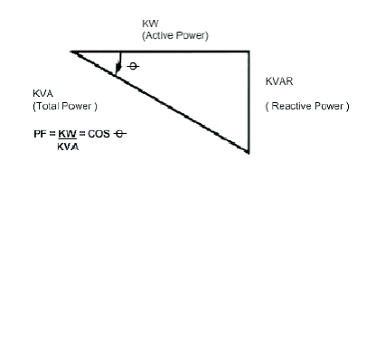
Figure 3.7 Power Triangle [37]
Reactive power (VARs) cannot be transmitted very far, especially under heavy load conditions, and so it must be generated close to the point of consumption. This is because the difference in voltage causes VARs to flow and voltages on a power system are only typically +/- 5% of nominal. This small voltage difference will not cause substantial VARs to flow over long distances. Real power (MW) can be transmitted over long distances through the coordinated operation of the interconnected grid whereas reactive power must be generated at, or near, the load center.
The reactive power or (MVARs) is important in this case because the reactive power availability, the speed at which it is produced, and the balance are critical to system voltage stability. Too much reactive power can cause over voltages and too little can cause to overload or low voltages and/or voltage collapse. Either scenario can cause widespread blackouts [28].

3.7.3 Limitation of Generated Power
Generators normally operate in voltage control mode in which an automatic voltage regulator (AVR) acts on the exciter of a synchronous machine. The exciter supplies the field voltage and consequently the current in the field winding. Within the capability limits of the machine, it can thereby regulate the voltage of the bus where it is connected. The response time of the primary controllers is short, typically fractions of a second, for generators with modern excitation systems. The amount of reactive power that a generator must produce to regulate the voltage depends on the structure and load situation of the surrounding transmission system [30].
When a generator of a heavily loaded electric power system reaches a reactive power limit (one fourth of short circuit apparent power at the receiving end), the system can become immediately overloaded and a dynamic voltage collapse leading to blackout, Also, when a generator of a heavily loaded electric power system reaches an active power limit (one half of short circuit apparent power at the receiving end), the system can become immediately overloaded and a dynamic voltage collapse leading to blackout [30].

3.7.4 Limitation of Transmission Lines
All lines, transformers, and other electrical equipment are heated by the current flowing through them. Line flows must be limited to prevent equipment from overheating. Most transmission lines, transformers, and other current-carrying devices are monitored continuously to ensure that they do not become overloaded or violate other operating limits. Multiple ratings are typically used, one for normal conditions and a higher rating for emergencies. The primary means of limiting the flow of power on transmission lines is to adjust selectively the output of generators.
Voltage, a pressure-like quantity, is a measure of the electromotive force necessary to maintain a flow of electricity on a transmission line. Voltage fluctuations can occur due to variations in electricity demand and to failures on transmission or distribution lines. Constraints on the maximum voltage levels are set by the design of the transmission line. If the maximum is exceeded, short circuits, radio interference, and noise may occur. Also, transformers and other equipment at the substations and/or customer facilities may be damaged or destroyed. Minimum voltage constraints also exist based on the power requirements of the customers. Low voltages cause inadequate operation of customer's equipment and may damage motors [38].
Voltage on a transmission line tends to drop from the sending end to the receiving end. The voltage drop along the AC line is almost directly proportional to reactive power flows and line reactance. The line reactance increases with the length of the line. Capacitors and inductive reactors are installed, as needed, on lines to, in part; control the amount of voltage drop. This is important because voltage levels and current levels determine the power that can be delivered to the customers [38].

3.7.5 Limitation of Transformers
Power transformers with on-load tap changers can scale the pv-curve along the v-axis and thereby increase the practical but not the theoretical transfer limit. Transformers equipped with tap changers can shift reactive power between their primary and secondary sides and thereby regulate the voltage of their low voltage side. The regulation of the low side voltage however affects the voltage at the high voltage side in the opposite direction. This effect is small under normal operation but may be a significant factor in voltage instability incidents.
When the tap ratio is increased, stiffness of the system is sacrificed and the practical transfer limit moves closer to the theoretical limit [30].
If heavily load is represented the tap changers have no effect, in this case another solutions must considers or the Protective Fused may work and disconnect the transformer.
An increase of the feeding voltage E scales the pv-curve along both axes and thereby increases the practical and theoretical transfer limits. The stiffness is slightly decreased and the practical and theoretical transfer limits are brought closer together. And the control range of the feeding voltage is usually limited since both line ends must comply with the practical voltage limit [30].
When the load increases the transformer temperature will rise and the ageing of insulating materials accelerates. Ageing sets certain limits to the load capacity of the transformer. The IEC loading guide considers as a normal the operation at the rated power when the ambient air temperature is 20C [35]. In this case, the insulating materials will age at the normal speed and a proper maintenance will be provided. In practice, however, the power transformer is very seldom continuously loaded at the same load.
The load and temperature can very according to the power demand and weather conditions. If part of the operation time the transformer loading is lower than its continuous load capacity it can be loaded more at the other times such that the ageing remains normal during the whole time [35].

3.7.6 Supply Interruptions
Faults on the power system are the most common cause, irrespective of duration. Other causes are failures in equipment, and control and protection malfunctions. Electrical equipments cease to function under such conditions, with under voltage protection devices leading to tripping of some loads.
Short interruptions may be no more than an inconvenience to some consumers (e.g. domestic consumers), but for commercial and industrial consumers (e.g. semiconductor manufacture) may lead to lengthy serious production losses with large financial impact.
Longer interruptions will cause production loss in most industries, as induction and synchronous motors cannot tolerate more than 1-2 seconds interruption without having to be tripped, if only to prevent excessive current surges and resulting large voltage dips on supply restoration [39].

3.7.7 Under-Voltage
Excessive network loading, loss of generation, incorrectly set transformer taps and voltage regulator malfunction cause under voltage. Loads with a poor power factor or a general lack of reactive power support on a network also contribute. The location of power factor correction devices is often important, incorrect location resulting in little or no improvement.
The symptoms of under voltage problems are tripping of equipment through under voltage trips. Lighting will run at reduced output. Under voltage can also indirectly lead to overloading problems as equipment takes an increased current to maintain power output (e.g. motor loads). Such loads may then trip on over current or thermal protection [40].

3.7.8 Harmonics
In an ideal power system, the voltage supplies to customers equipment, and the resulting load current are perfect sine waves. In practice, however, conditions are never ideal, so these waveforms are quite often distorted. This deviation from perfect sinusoids is usually expressed in terms of harmonic distortion of the voltage and current waveforms.
This is a very common problem in the field of power quality. The main causes are power electronic devices, such as rectifiers, inverters, UPS systems, static VAR compensators, etc. Other sources are electric discharge lamps, arc furnaces and arc welders.
In fact, any nonlinear load will be a source of harmonics. Figure 3.8 illustrates a supply waveform that is distorted due to the presence of harmonics. Harmonics usually lead to heating in rotating equipment (generators and motors), and transformers, leading to possible shutdown. Capacitors may be similarly affected. If harmonic levels are sufficiently high enough, protective devices may shut the equipment down to avoid damage.
Overloading of neutral conductors in LV systems has also occurred (the harmonics in each phase summing in the neutral conductor, not canceling) leading to failure due to overheating. Some equipment, such as certain protection devices, may maloperate and cause unnecessary shutdowns [39].

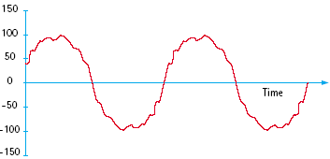

Figure 3.8 Supply Waveform Distorted due to the Presence of Harmonics [39].

3.8 Overload Elimination
Power systems undergo frequent changes due to outages and demand variations. These changes may result in one or more branch (transmission lines or transformers) overloads.
In order to keep the system within secure operating conditions, control actions must be taken so as to eliminate such overloads. Possible control actions are described below:
A. Short term:
- adjust phase-shift transformers and switch capacitor banks and reactors
- transfer the load from one part of the system to another
- increase output of the active and reactive power of generators and synchronous compensators via their permissible short-term overloading
- curtail loads of the lowest priority
- switch-off of the radial transmission lines

B. Long term:
- Increase the capability of transfer power of the transmission lines by:
- Convert from single conductor to bundle conductors
- Add new transmission lines parallel to the most loaded T.L.
- Increase the size of transmission line.
- Raise transmission voltage by replacing the transformer by another transformer with higher sending voltage.
- Increase the generation capacity by:
- Add reserve generators in the power plant
- Add distribution generators to the systems
- Add synchronous condensers
- Increase the capacity of the distribution transformers by adding reserve parallel distribution transformers.
- Maintenance of LV transmission lines or cables
In this thesis some of the long term voltage instability solutions of the overload power system problem will be considered so the following section will explains these solutions in details.

3.8.1 Long Term Solutions for Alleviation Overload
The electricity industry has always been interested in expanding investment in the all power system sectors of the industry. As load demand increases and generation expands to meet the need, transmission expansion becomes important in order to increase social welfare by reducing total system operating cost, and to make the system more reliable.

3.8.1.1 Transmission Line (TL)
The purposes of expanding transmission line by convert from single conductor to bundle conductors, or add new transmission lines parallel to the most loaded TL are to increase the capability of transfer power of the transmission lines. The bundled conductor can be two or three or four.
The expansion will be by convert from single conductor to bundle (two wires), and by adding parallel conductor to the old one using the characteristics of all aluminum conductor (AAC) in appendix A table B1.
To see the effecting in voltage and current of the transmission line, one proposed power system circuit will be implemented which contain one diesel generator, step-up transformer transmission line with 40 km distance, step down transformer and one load has 18.9 MVA apparent power with shown in figure 3.9.
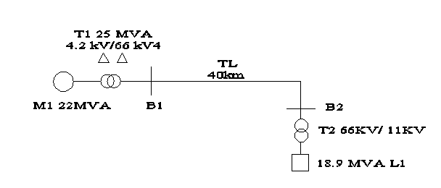
Figure 3.9 Simple Example of Power System.

To have the results three different experiments will be implemented using Matlab software program (simulate power system). In Matlab program the Distributed Parameter Line block implements an N-phase distributed parameter line model with lumped losses. The model is based on the Bergeron's traveling wave method used by the Electromagnetic Transient Program (EMTP) [41].
Multiphase networks can be extended to multiphase networks by formally replacing scalar quantities with matrix quantities. This generalization is straightforward for coupled lumped inductances. The program of [41] has an input option for multiphase Pi-circuits, which are solved with the matrix equivalent of the scalar equations and for the series impedance matrix and for the shunt capacitance matrix. Cascade connections of such multiphase Pi-circuits can be used to model lines with any number of phases, e.g., parallel un-transposed lines on the same right of way. Pi-circuits must be used on network analyzers, but digital computers offer a better alternative which avoids the problem of cutoff frequency.
The first experiment contains just 40 km transmission line between the generation part and load part. In the second experiment, the 40 km transmission line is converted to the bundled two conductors with angle zero as shown in figure 3.10. In the third experiment, a parallel transmission line is added to the 40 km transmission line as shown in figure 3.11. Table 3.1 shows the impedance values (RLC) in these different experiments and the results will be noted in table 3.2 which contains the voltage drop and current.

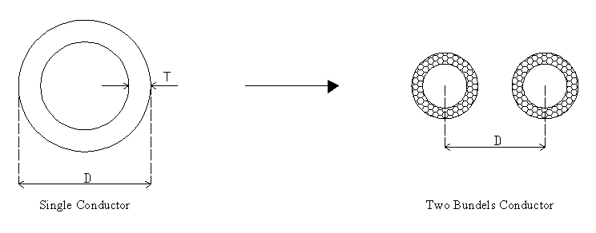
Figure 3.10 Converting from Single to Bundle Conductor.

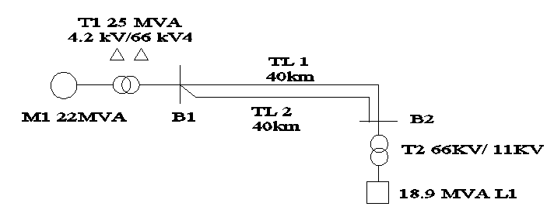
Figure 3.11 Simple Example of Power System with Parallel Line.

Table 3.1 RLC values 40km Transmission Line
- | Single Conductor | Bundle conductor
Resistance (ohm/km) | 0.1659 | 0.082952
Inductance(mH/km) | 1.5399 | 1.1782
Capacitance(nF/km) | 7.4919 | 9.6997

Table 3.2 Results Values
- | Single Conductor | Bundled Conductor | Parallel Conductor
Voltage Drop | 2550 V | 1923 V | 1309 V
Current | 125 A | 128 A | 130 a

From table 3.2 we can see the different in voltage for single conductor to the bundle 2550V to 1923V approximately 75% and to the parallel conductor 51%. The small different in current comes from the different impedances of the load. These values are not standard values and it is different from one power system to another. By referring to the chapter two section 2.2.2.5 Characteristic Impedance of transmission line, table 3.3 shows the range of characteristic impedance values for a variety of lines, including bundled conductor lines.
The characteristic impedance will vary according to the distance between conductors, distance to ground, and the radius of the individual conductor. If the change of impedances values will be noticed, considering for example the difference of a single transmission line and bundle transmission line, the minimum impedances values which are 350 for phase to ground and 650 for phase to phase for single conductor become 250 for phase to ground and 500 for phase to phase for Bundled (2-wire). As it is known when the impedance value is increased the voltage value will increased as $V=\text{ZI}$and vise versa.

Table 3.3 Range of Characteristic Impedances on Overhead Lines [23]
Transmission Line Conductor  (Each Phase) | Characteristic Impedance(ohms)
_ | Phase to Ground | Phase to Phase
Single Wire | 350-500 | 650-800
Bundled(2-wire) | 250-400 | 500-600
Bundled(4-wire) | 200-350 | 420-500

To show the effect of adding parallel TL, the following example is introduced. Below in figure 3.12 is a 2-bus system with two transmission lines.

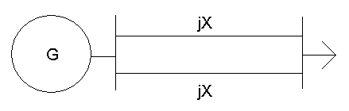
Figure 3.12 Two Bus System with Parallel Transmission Line [29]

For the above diagram we will assume the values of 1.2 and 0.8 p.u. for the reactances of the transmission lines, 1 p.u. for the value of the generator bus |V₁|, and a unity power factor at the load bus (i.e. ß = 0). The combined reactance for this two transmission line system is X = 0.48 p.u. For purposes of simplicity of all forthcoming plots we have rounded this to X = 0.5 p.u. Below in figure 3.13 is the representative PV plot for this two transmission line system with X = 0.5 p.u.
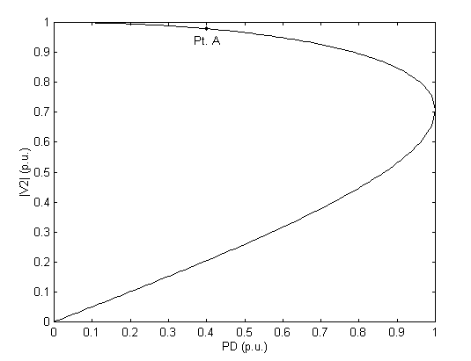
Figure 3.13 P-V Curve of Two TL with X = 0.5 pu. [29]

Just as above, the PV curves that follow are based on the assumption of a two transmission line system operating with different line reactances. Should something occur to cause a loss of a transmission line, the PV plot would change to look like one of the plots below as shown in figure 3.13 and figure 3.14.
Figure 3.14 shows the PV curve that would result if the transmission line that failed had a high reactance and the remaining operable line had a low reactance (X = 0.8 p.u.).
Figure 3.15 shows the PV curve that would result if the transmission line that failed had a low reactance and the remaining operable line had a high reactance (X = 1.2 p.u.). The plot shows that the operating point A move to the second position nearly approaches the condition of "voltage collapse".

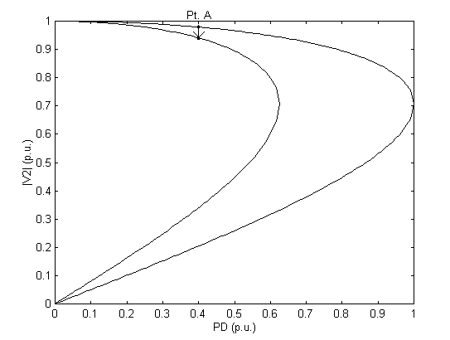
Figure 3.14 P-V Curve if The Lower Impedance is Only Working. [29]
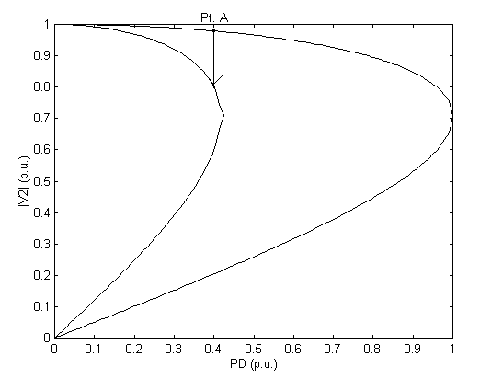
Figure 3.15 P-V Curve if The Higher Impedance is Only Working [29]

On both plots Pt. A now lies on the smaller PV curve. This places the system below normal operating parameters and the large voltage drop creates a breach of voltage security.

Theoretically for single conductor, the sent apparent power $S_{1}$ is
$S_{1}=V_{1}I_{1}$ (3.6)
and the voltage drop ${ΔV}_{1}$ is given by
${ΔV}_{1}=Z_{1}I_{1}$ (3.7)
For bundle conductor, the sent apparent power $S_{2}$ is
$S_{2}=V_{2}I_{2}$ (3.8)
and the voltage drop ${ΔV}_{2}$ is given by
${ΔV}_{2}=Z_{2}I_{2}$ (3.9)
For parallel conductors, the sent apparent power $S_{3}$ is
$S_{3}=V_{3}I_{3}$ (3.10)
and the voltage drop ${ΔV}_{3}$ is given by
${ΔV}_{3}=Z_{3}I_{3}$ (3.11)
As we see from table 3.1 $Z_{1}>Z_{2}$ so the voltage drop ${ΔV}_{1}$ will be greater than ${ΔV}_{2}$ and will also greater than ${ΔV}_{3}$. If the voltage for single conductor at the receiving end $V_{1R}$, the voltage for bundle conductor at the receiving end $V_{2R}$, and the voltage for parallel conductors at the receiving end $V_{3R}$, then they can be calculated from the following equations.
$V_{1R} = V_{1} − {ΔV}_{1}$ (3.12)
$V_{2R} = V_{2} − {ΔV}_{2}$ (3.13)
$V_{3R} = V_{3} − {ΔV}_{3}$ (3.14)
As $V_{1} = V_{2} = V_{3}$, then
$V_{2R} > V_{1R}$ (3.15)
Also,
$Z_{1}\text{//}Z_{3}$ (3.16)
If $Z_{1}=Z_{3}=Z$ (3.17)
then $Z_{\text{eq}}=0\text{.}5Z$ (3.18)
and ${ΔV}_{3}=0\text{.}5{ΔV}_{1}$ (3.19)
and $V_{3R} > V_{1R}$ (3.20)
Also as discussed in section 3.4 the short circuit apparent power for the three cases at the receiving end are given by
$S_{1\text{SCR}} = V_{1^{2}}Z_{1}$ (3.21)
$S_{2\text{SCR}} = V_{2^{2}}Z_{2}$ (3.22)
$S_{\text{31}\text{SCR}} = V_{3^{2}}0\text{.}5Z$ (3.23)

As $Z_{1}>Z_{2}$, then
$S_{2\text{SCR}} > S_{1\text{SCR}}$ (3.24)
And the maximum transport active power $P_{2}$ for $Q_{2} = 0$will be greater than $P_{1}$, and the maximum transport reactive power $Q_{2}$for $P_{2} = 0$ will be greater than $Q_{1}$.
Also in the parallel conductors case,
$S_{3\text{SCR}} = 2 S_{1\text{SCR}}$ (3.25)
Then the maximum transport active power $P_{3}$ for $Q_{3} = 0$will be double $P_{1}$, and the maximum transport reactive power $Q_{3}$ for $P_{3} = 0$ will be double $Q_{1}$.
Also to get similar effect of bundle or parallel wire, raising transmitting voltage can be used. Consider for simplicity that the transmitting voltage is doubled, or in other words become $V_{\text{new}} = 2 × V_{1}$, and consider the same transmitted power, then
$I_{\text{new}} = 1l2 × I_{1}$ (3.26)
$∇V_{\text{new}} = 1l2 × ∇V_{1}$ (3.27)
$V_{\text{Rnew}} = V_{1} − 1/2 × ∇V_{1}$ (3.28)
$V_{\text{Rnew}} > V_{\text{Rold}}$ (3.29)
Also, the power loss before doubling the voltage was
$P_{\text{loss}} = 3 × I^{2} × R$ (3.30)
then, the power loss after doubling the voltage will be
$P_{\text{loss} \text{new}} = 3 × I_{{\text{new}}^{2}} × R$ (3.31)
$P_{\text{loss} \text{new}} = 3 × I_{1^{2}} × R / 4$ (3.32)
$P_{\text{loss} \text{new}} = 1/4 × P_{\text{loss} \text{old}}$ (3.33)
$P_{r} = P_{t} −P_{\text{loss}}$ (3.34)
$P_{\text{rnew}} = P_{t} −P_{\text{loss} \text{new}}$ (3.35)
$P_{\text{rnew}} = P_{t} − 1/4 ×P_{\text{loss} \text{old}}$ (3.36)

As the power loss after doubling the voltage is one forth of the power loss of the old voltage, then the received power will also be increased and the voltage at the receiving end will be increased more.

3.8.1.2 Distributed Generators
Distributed generation is an electric power source connected directly to the distribution network or on the customer side of the meter [40].
Distributed generators (also known as Distributed Resources) come in many forms including gas turbine driven synchronous generators, wind powered induction generators, fuel cells with inverter circuitry, and others. The use of distributed resource generation is projected to grow. This growth is due to cost reductions available with distributed generators. The cost reductions may be the result of released system capacity or reductions in generation costs at peak conditions.
In the evolving energy industry, emerging distributed generator technologies have the potential to provide attractive, practical, and economical generation options for energy companies and their customers.
Starting emergency generation at the load end will support the load end with reactive as well as active power, reduce the load of the limited generators and support the voltage at the load end, improve the service and delivery of energy to end users, and support the operation and management of transmission and distribution systems [40].

Table 3.4 Distribution Generator Rating [40]
Distribution Generator | Approximate Values
Micro distributed generation | 1Watt < 5kW
Small distributed generation | 5 kW < 5 MW
Medium distributed generation | 5 MW < 50 MW
Large distributed generation | 50 MW < 300 MW

These generators are usually built in the substations and do not consider the islanding of distributed generators (that is the generator operating without substation supply).
A distributed generator is often placed at a substation because no further land purchases are needed. However, locating generators at substations, distributed generator acts only as a back up power source, which may not contribute significant reliability improvement as far as the entire system is concerned. Instead, generators located further out on a circuit can often significantly affect system reliability. It is necessary to evaluate the effects of different placements of distributed generators [40].

3.8.1.3 Synchronized Generator
It’s always often to connect two or more generators in parallel to supply a common load. For example, as the power requirements of a large utility system build up during the day, generators are successively connected to the system to provide the extra power. Later when the power demand falls, selected generators are temporarily disconnected from the system until power again builds up the following day. Synchronous generators are therefore regularly being connected and disconnected from a large power grid in response to customer demand. Such a grid is said to be an infinite bus because it contains so many generator essentially connected in parallel that neither the voltage nor frequency of the grid can be altered.
Before connecting a generator to infinite bus (or in parallel with another generator), it must be synchronized. A generator is said to be synchronized when it meets all the following conditions:
- The generator frequency is equal to the system frequency.
- The generator voltage is equal to the system voltage.
- The generator voltage is in the phase with the system voltage.
- The phase sequence of the generator is same as that of the system.
To synchronize an alternator, we proceed as follows:
- Adjust the speed regulator of the turbine so that the generator frequency is close to the system frequency.
- Adjust the excitation so that the generator voltage Eo is equal to the system voltage E.
- Observe the phase angle between Eo and E by means of a synchroscope. This instrument has a pointer that continually indicates the phase angle between the two voltages, covering the entire range from zero to 360 degrees.
- The line circuit breaker is closed, connecting the generator to the system. In modern generation stations, synchronization is usually done automatically [1].

      - Parallel Operation of Transformers
The efficiency of the transformer varies anywhere between 96 to 99 percent. The efficiency of the transformers not only depends on the design, but also, on the effective operating load.
The control set voltage is dependent upon the regulator rating and the system voltage on which it is installed. The regulator nameplate shows the voltage transformer or shunt winding/control ratio that corresponds to the system voltage. The regulator load voltage is the product of this ratio and the control set voltage [25].
For supplying a load in excess of the rating of an existing transformer, two or more transformers may be connected in parallel with the existing transformer. It is usually economical to install another transformer in parallel instead of replacing the existing transformer by a single larger unit. The cost of a spare unit in the case of two parallel transformers (of equal rating) is also lower than that of a single large transformer.
In addition, it is preferable to have a parallel transformer for the reason of reliability. With this, at least half the load can be supplied with one transformer out of service. For parallel connection of transformers, primary windings of the transformers are connected to source bus-bars and secondary windings are connected to the load bus-bars. There are various conditions that must be fulfilled for the successful parallel operation of transformers. These are as follows [42]:

- The line voltage ratios of the transformers must be equal (on each tap): If the transformers connected in parallel have slightly different voltage ratios, then due to the inequality of induced emfs in the secondary windings, a circulating current will flow in the loop formed by the secondary windings under the no-load condition, which may be much greater than the normal no-load current. The current will be quite high as the leakage impedance is low. When the secondary windings are loaded, this circulating current will tend to produce unequal loading on the two transformers, and it may not be possible to take the full load from this group of two parallel transformers (one of the transformers may get overloaded).
- The transformers should have equal per-unit leakage impedances and the same ratio of equivalent leakage reactance to the equivalent resistance (X/R): If the ratings of both the transformers are equal, their per-unit leakage impedances should be equal in order to have equal loading of both the transformers. If the ratings are unequal, their per-unit leakage impedances based on their own ratings should be equal so that the currents carried by them will be proportional to their ratings. In other words, for unequal ratings, the numerical (ohmic) values of their impedances should be in inverse proportion to their ratings to have current in them in line with their ratings. A difference in the ratio of the reactance value to resistance value of the perunit impedance results in a different phase angle of the currents carried by the two paralleled transformers; one transformer will be working with a higher power factor and the other with a lower power factor than that of the combined output. Hence, the real power will not be proportionally shared by the transformers.
- The transformers should have the same polarity: The transformers should be properly connected with regard to their polarity. If they are connected with incorrect polarities then the two emfs, induced in the secondary windings which are in parallel, will act together in the local secondary circuit and produce a short circuit. The previous three conditions are applicable to both single-phase as well as three phase transformers. In addition to these three conditions, two more conditions are essential for the parallel operation of three-phase transformers:
- The transformers should have the same phase sequence: The phase sequence of line voltages of both the transformers must be identical for parallel operation of three-phase transformers. If the phase sequence is an incorrect, in every cycle each pair of phases will get short-circuited.
- The transformers should have the zero relative phase displacement between the secondary line voltages: The transformer windings can be connected in a variety of ways which produce different magnitudes and phase displacements of the secondary voltage. All the transformer connections can be classified into distinct vector groups. Each vector group notation consists of first an uppercase letter denoting HV connection, a second lowercase letter denoting LV connection, followed by a clock number representing LV winding’s phase displacement with respect to HV winding (at 12 o’clock). There are four groups into which all possible three-phase connections can be classified:
Group 1: Zero phase displacement (Yy0, Dd0, Dz0)
Group 2:180° phase displacement (Yy6, Dd6, Dz6)
Group 3: -30° phase displacement (Yd1, Dy1, Yz1)
Group 4: +30° phase displacement (Yd11, Dy11, Yz11)
In above notations, letters y (or Y), d (or D) and z represent star, delta and zigzag connections respectively. In order to have zero relative phase displacement of secondary side line voltages, the transformers belonging to the same group can be paralleled. For example, two transformers with Yd1 and Dy1 connections can be paralleled. The transformers of groups 1 and 2 can only be paralleled with transformers of their own group. However, the transformers of groups 3 and 4 can be paralleled by reversing the phase sequence of one of them. For example, a transformer with Yd1 1 connection (group 4) can be paralleled with that having Dy1 connection (group 3) by reversing the phase sequence of both primary and secondary terminals of the Dy1 transformer [42].

3.10 Summary
This chapter discussed the load specification and voltage phenomena in general, after that it identified the main causes of the overload power system. Finally, some solutions to eliminate overload was discussed in detail. Next chapter will deal with part of these solutions to eliminate overload and some comparisons.

